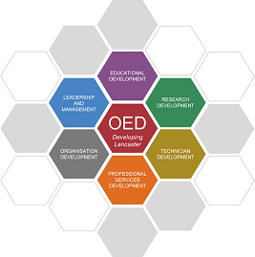

Lancaster Professional Programme - Personal Learning Reflective Statement

Please complete a separate journal for each development event/activity.
Name: |  | Date:

Submission for:(please delete as appropriate) | Bronze | Silver | Gold

Stage 1: Describe the learning activity
Choose a learning or development activity that has been a positive experience for you and has made you reflect on your own practice and behavior.
Describe in detail the development event that you are reflecting on. Include, for example, where were you; who else was there; why were you there; what were you doing; what were other people doing; what was the context of the event; what happened; what was your part in this; what parts did the other people play; what was the result.

Stage 2: Describe your Observations and Reflections
At this stage try to explore how you were feeling – what was going on inside your head. Describe how you were feeling when the activity started; what you were thinking about at the time; how did other people make you feel; how did you feel during and about the outcome of the event; what do you think about it now.
How did your feelings influence your behavior, i.e. what did you say or do?
Also, describe any ‘key moments’ or ‘key observations’, e.g. something someone said or something that was taught that had an impact on you or particularly chimed with you for some reason. Describe why it was a ‘key moment’ for you. Key observations could include how you noticed others responded and/or they maybe a model or theory that made sense or helped you with your understanding.
Consider what was good and/or bad about the learning event or experience or what went well or worked well or didn’t go so well for you.

Stage 3: Key learning points and conclusions
At this stage, describe the key learning points or outcomes for you, e.g. aspects of the activity that were particularly relevant or stood out to you.
What conclusions do you draw from the learning?
If the learning activity was a workshops, you should try to relate the learning to your practice in the workplace. By doing this you are likely to develop insight into you own and other people’s behaviour in terms of how they contributed to the outcome of an event.
Remember the purpose of reflection is to learn from an experience. Without detailed analysis and honest exploration that occurs during all the previous stages, it is unlikely that all aspects of the event will be taken into account and therefore valuable opportunities for learning can be missed. During this stage you should ask yourself what you could have done differently.

Stage 4: So what? - Action Planning
During this stage you should think yourself forward into encountering the event or workplace scenario again and to plan what you would do – would you act differently or would you be likely to do the same? Here the cycle is tentatively completed and suggests that should the event occur again it will be the focus of another reflective cycle

