Formative assessment – or assessment for learning – is a powerful way to enable dialogue between students and teachers about learning and understanding.

Designing formative assessment
The ingredients for successful formative assessment include a learning task by which students produce some type of assessable output, the provision of timely feedback about the students’ work to given criteria, and the requirement for students to act on that feedback to provide opportunity to apply their learning to improve the quality of their work.
A common challenge, however, is how to motivate students to complete formative assessments when they hold limited or no weighting towards the final mark. Effective formative assessment involves task, feedback and dialogue, but is also valued by students through its relationship to summative assessment.
Presented here is a ‘five-step check’ that can be used to check against principles of effective feedback, and consider the extent to which students are motivated to engage meaningfully in formative tasks in order to improve their learning. The tool can be used to review both new and existing formative assessment tasks and feedback potential.

The five steps
1. Purposes: what is the feedback for?
2. People: who provides the feedback?
3. Act: how will students respond?
4. Learning: how will students learn as a result?
5. Making it count: is the task and feedback valued?

1. Purposes

What is the purpose of the feedback? Is it to…
- Help students to clarify what good performance is?
- Deliver insight to learners about their current performance?
- Provide guidance on how to close the gap between current and desired performance?
- Prompt self-assessment or reflection?
- Encourage dialogue about a learning topic?
- Motivate students and encourage positivity?
- Gather information that can be used to shape teaching?
From Nicol & MacFarlane-Dick, 2006. More than one may apply.

2. People

Who will provide this feedback and how?
A range of stakeholders can provide feedback, each offering different benefits to the student. Whilst tutors may conventionally provide feedback, this does not necessarily have to occur on an individual basis, and providing summary group feedback could be a way to alleviate workload pressures, particularly with large groups. Peer feedback and self-evaluation can develop critical thinking, analysis and reflection for the reviewer as well as reviewee; In practice contexts mentors may be suitable feedback providers; External sources such as special interest groups, online communities, audiences etc. may also provide help students consider their learning from a professional or community perspective.

3. Act

How are students required to act on feedback and resulting dialogue be captured and shared?
Consider the format for feedback and its suitability for the learning task. Feedback could be verbal, written or group based, and could be captured via audio/video recordings, notes, annotations, mind maps etc.. Provide some guidance to students about how they should expect to receive feedback, or are expected to provide it to one another.

4. Dialogue and learning

How will the student use the feedback in their learning?
Providing guidance about the task will also demand inclusion of what you expect students to do with their feedback. This is likely to involve a response that sustains the dialogue resulting from the initial feedback provided. For example, you might ask students to: Reflect on their current learning and understanding; Make changes to their assignments; Propose changes to practice.

5. Making it count

How is the formative task, feedback and dialogue valued by students?
Formative tasks provide a ‘pinch point’ for students to externalise their learning and understanding. The outputs they produce as a result can be used as a focal point for feedback and dialogue about their own learning. A key strategy for engaging students in the completion of formative tasks is to make them count towards the summative work for which they will receive a grade. How do the outcomes of the task contribute, either directly or indirectly, to assignment work? This approach can be particularly effective where students need to provide evidence of their evolving thinking or changing practice – such as in a professional learning programme.

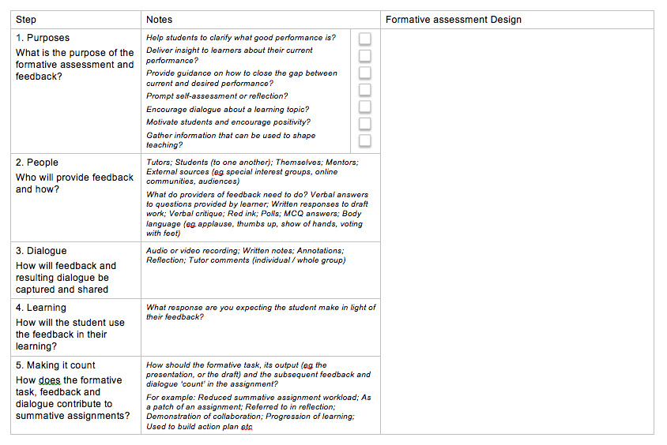

Simon Allan, Curriculum and Education Development Academy
v2 updated August 2021

